**The S&P 500 *Double Topped*, will we now see a Break of the 50 SMA?**

[**This Week's Trade Ideas:**](https://word-edit.officeapps.live.com/we/wordeditorframe.aspx?ui=en-US&rs=en-US&hid=71d5fe60-cffe-46f6-86c5-a1f38925eb8d&WOPISrc=https%3A%2F%2Fwopi.onedrive.com%2Fwopi%2Ffiles%2F5B5C1B044F8F8575%213254&wdPid=67ba5c08&wdo=2&wde=docx&sc=host%3D%26qt%3DFolders&mscc=1&wdp=0#tradeideas)

**Bullish Ideas: (View Webinar)**

**XOM > Exxon Mobil Corp. > $86.51** Last. Buy the Oct. 26th 84.5 Calls for $3.05 or less with a close or anticipated close above $87.08 in an up market with expectations for continued strength in the major indices.

Bullish Mentions: **(View Webinar)**

Based upon closing prices and all assume an up market with expectations for continued strength in the major indices.

**XLE, OIH, XOM, APC, NBL, NOV, DO, TS, FB*.**

**Bearish Ideas:**

**(View Webinar) SYY > Sysco Corp. > $71.80** Last. Buy the Nov. 2nd 73 Puts for $1.90 or less with a close or anticipated close below $71.73 in a down market with expectations for continued weakness in the major indices

Bearish Mentions:

Based upon closing prices and all assume a down market with expectations for continued weakness in the major indices.

Shockingly, none at this time.

We strongly suggest viewing this week’s **Morning Call** webinar for full details with respect to these idea(s), last week’s and options education.

**Special Note:**

Remaining nimble is a focus in the newsletter and in our **Morning Call** webinar and will be so.

Outlook:

Last week’s Outlook:

*With a negligible difference between where the* ***SPX*** *was last Tuesday and where we are this Tuesday, we’re not impressed…not quite yet. The markets have held above key support and the new NAFTA news certainly got the week off to a strong start, but the past 2 candles have left us nonplussed. The market should be ready for a rally attempt, but it’s lacked enthusiasm so far this week. A watchful eye must be kept.*

That outlook was the best we could muster last Tuesday, and it turned out to be a solid one. When we held last Wednesday’s webinar we could see that the day’s candle was already looking shaky. With the 50 SMA right near 2880 in the SPX, we have to believe that a drop below there brings more sellers out of the woodwork and makes the next level down a likely target. We must keep that watchful eye working *OT* this week.

Technicals:

Will be discussed in-depth in the **Morning Call** webinar.

Fundamentals:

These trade idea(s) and mentions are technically-driven.

(Editor's note: These trade ideas may be updated periodically, in keeping with market conditions. It is intended solely for educational purposes.)

**Recap of Last Week:**

Last week was easy in the sense that I showed us 3 bearish candles from Monday through Wednesday. Wednesday the SPX barely closed above the support line of our rising wedge that had us concerned for some time. We were already in “prudent mode”, and then we got a break below the support line of the rising wedge. It was down from there and the weakness that followed persisted all the way to about 1 PM EST on Monday.

**HAL, GLD, NEM, DE, MO,** and **TSRO** were our bullish names from last week and they never had a chance to be considered since the market was so heavy and certainly was not an “up market”.

The bears were **GT,** **PFE, RTH,** and **OKTA. GT** was the official idea and the others were mentions.

At this writing, **GT** dropped to $21.63 from last Tuesday’s close of $23.43.

**PFE** refused to break below its support line and so it couldn’t be considered which is a disappointment.

**RTH** dropped $3.00 of the $4.00 we were shooting for since last Tuesday and still hasn’t made it to our lowest target level.

**OKTA** dropped from $68.00ish last Tuesday to a low near $59.00 today which closed the gap target and lowest level target we outlined last week so we can’t complain about that.

In summary, last week provided drop that was pretty good for us in 3 of our 4 bearish names and all bullish names were easily avoided so there was solid potential there. We’re mainly happy over the fact that we went into *prudent mode* the week before and remained that way due to the weak action at the start of last week. We regret not being able to dig up more bearish names initially because once more became available, they’d already fallen quite far on Thursday.

**Market Overview**

After covering the charts last week, we included this passage in **Market Overview**:

*“Maybe it is us, but we still sense some trouble here despite the surface being very placid, maybe too placid.”*

We then place BTR-type material in this section as well:

*We’d normally place material like this in our* ***BTR*** *section below but given our switch to “Prudence” last week we thought it warranted being featured here.*

We became curious as the Fear / Greed readings were “too neutral” for our taste:

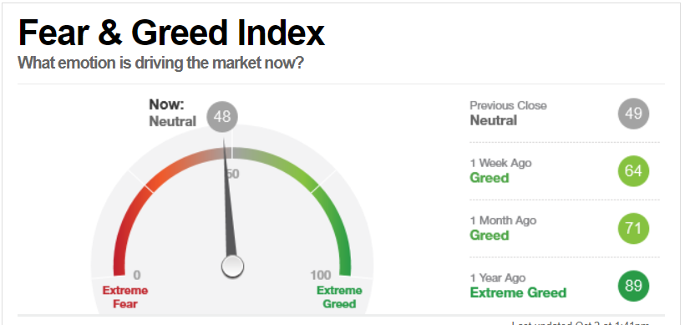

So, we dug deeper:

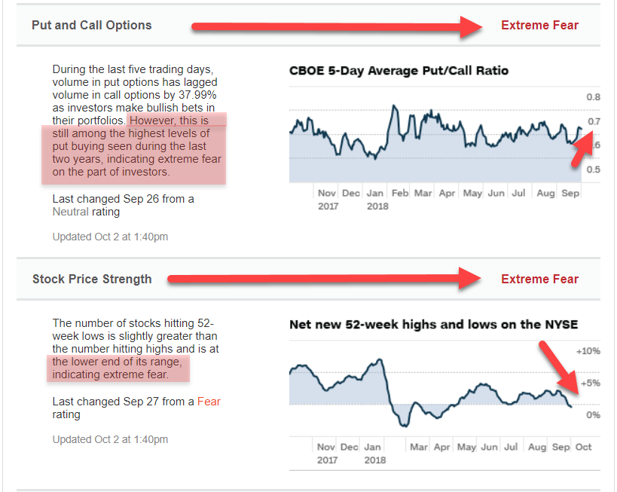

And we also found this material:

*PUT BUYING is the highest it’s been in 2 years which tells us that other option players have gone “prudent” along with us.*

*Many stocks making new 52-week lows informs us that* ***weakness below the surface of the market continues to be masked*** *by the big names getting Jamma, Jamma, Jamma’d upward!*

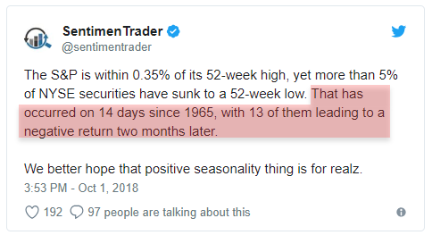

*Option players “insuring” themselves in a big way WITHOUT pushing the VIX up is very, very interesting to us. Some must be sensing what we’re sensing and that’s that all isn’t right with this market. The “rising wedge” has been our technical driver in that vein but clearly that’s only reflective of a potentially important factor that’s lurking in the real world that those in the know are privy to and of course which we are not. Maybe this will turn out a lot like the curious-to-us VIX levels that seemed too high for late August and subsequently turned out to be. Or, maybe our* ***Spider Sense*** *will get one right! Whatever the case, we’re sticking with prudence for the time being.*

We also included this snippet in Market Overview because our **Spider Sense** told us to do so:

See **BTR** below for more perspective because we’re not alone: <https://www.zerohedge.com/news/2018-09-26/insider-selling-soars-fastest-pace-september-sales-past-decade>

Seems like those insiders new when to ramp up their sales, that’s for sure!

Sometimes we compile and write the newsletter and wonder when what we think we’re seeing will matter. That was the case with respect to the “rising wedge” pattern for the longest time. Finally, last week it, and other facets, began to matter. We’re pleased that we were prepared for it.

As for this week:

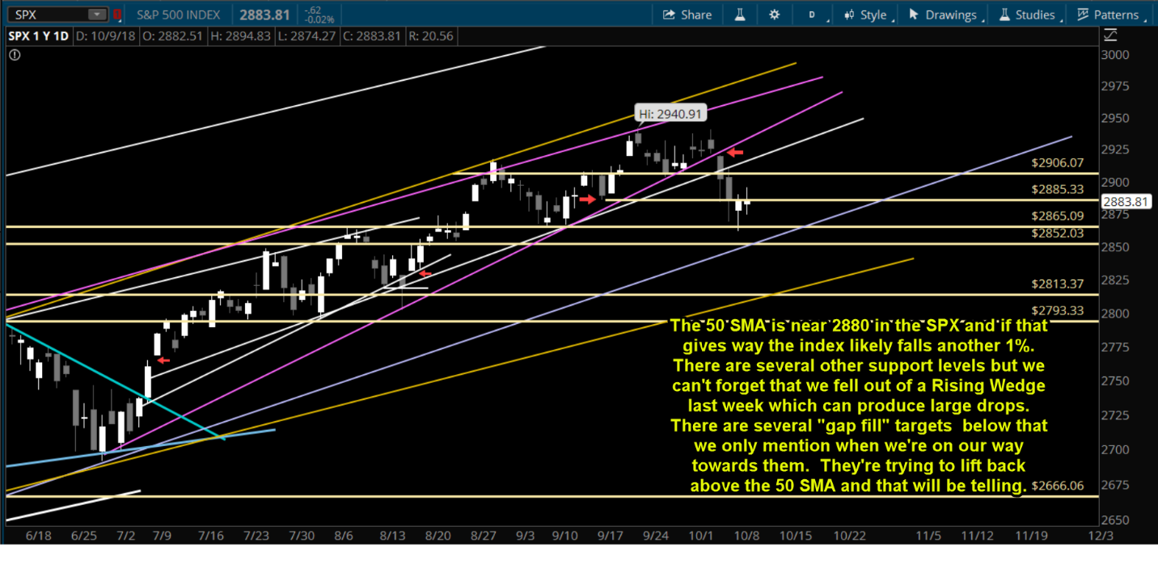

The double top we thought we might be seeing turned out to be what we were seeing. Now we’ll begin to see if there’s more to it beyond a sharp but short-term selloff. Unfortunately for bulls, the FAANG basket of leadership stocks looks challenged:

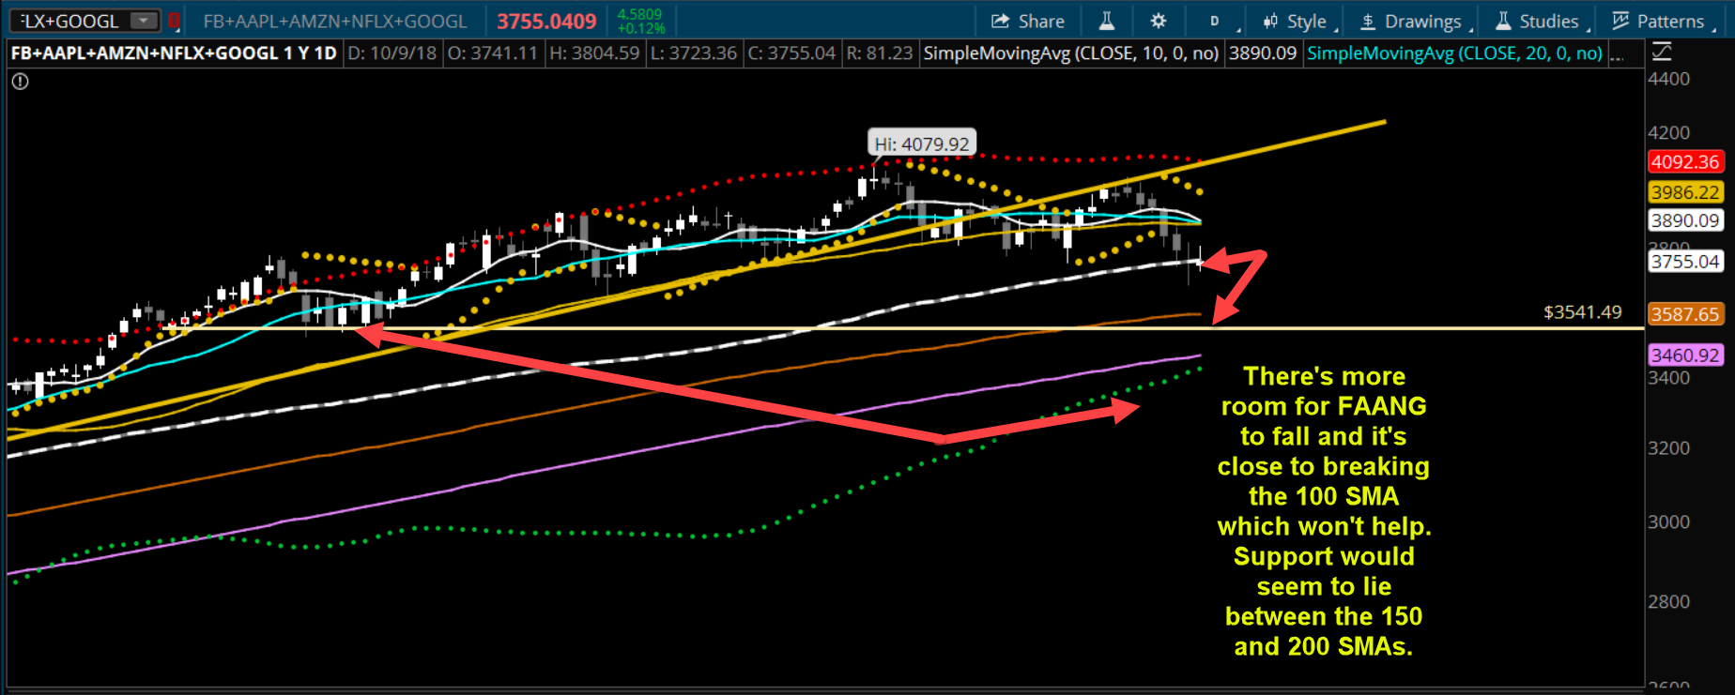

Naturally, with FAANG under assault, the rest of priced-to-perfection-*Techland* has come under pressure too: 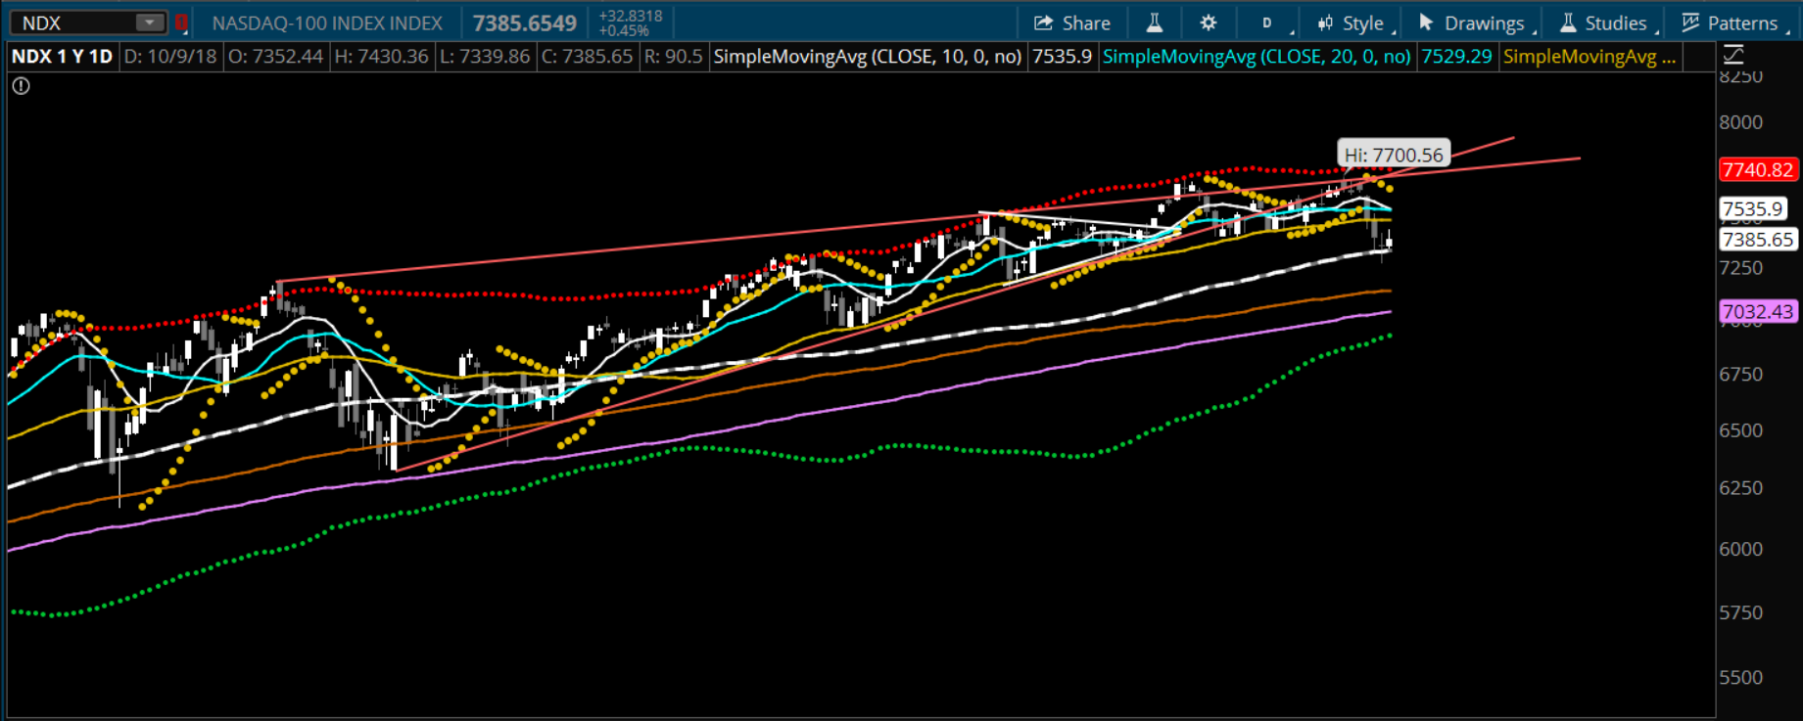

Even the DOW, which is blue chip laden, has started to feel it, the selling that is:

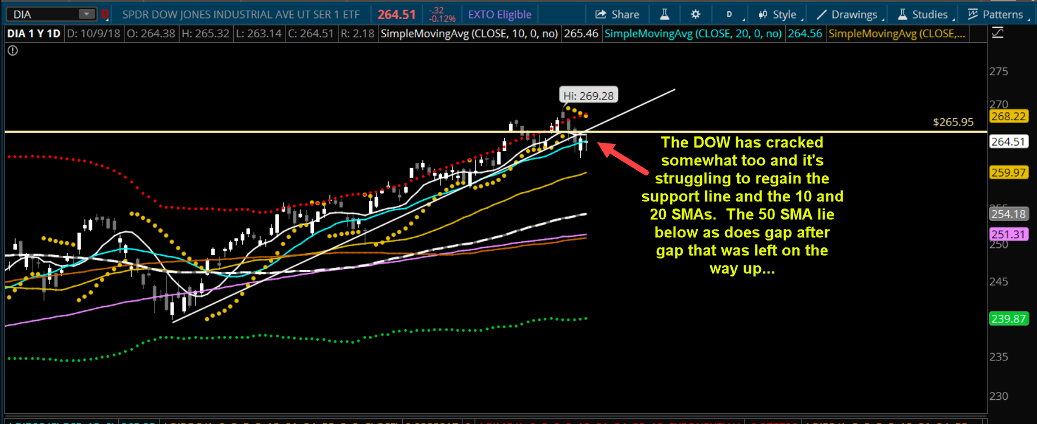

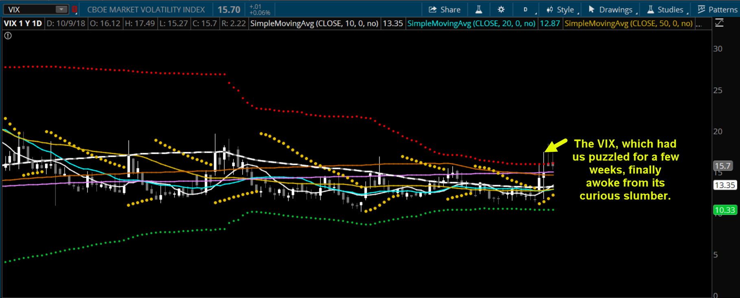

We’ll go more in-depth in our webinar, but the bottom line is that Rising Wedge support gave way and that alone is a good reason to believe that more downside is most definitely possible. We’re not super-oversold yet either but to counter those factors we can note that there should be/could be many support levels that would slow a decline on the way down. We believe that we must remain on guard for now until we see the indices put themselves on better footing.

We have what’s a pretty average calendar on the way this week. What we can say about it is that when market volatility jumps as it has, the Wall St. gang will often use releases to orchestrate outsized moves to help themselves balance out their positions. So, there’s that…

**This Week’s Economic Calendar**

|  |  |  |  |  |  |
| --- | --- | --- | --- | --- | --- |
| TIME (ET) | REPORT | PERIOD | ACTUAL | MEDIAN FORECAST | PREVIOUS |
| MONDAY, OCT. 8 | | | | | |
| 9 pm | [IMF World Economic Outlook](https://www.marketwatch.com/story/imf-downbeat-on-global-economic-outlook-2018-10-08) | 2019 | 3.7% | -- | 3.9% |
| TUESDAY, OCT. 9 | | | | | |
| 6 am | [NFIB small-business index](https://www.marketwatch.com/story/small-business-sentiment-retreats-from-45-year-high-nfib-says-2018-10-09) | Sept. | 107.9 | -- | 108.8 |
| 8 am | [Robert Kaplan speaks](https://www.marketwatch.com/story/feds-kaplan-says-he-doesnt-expect-sudden-spike-in-inflation-2018-10-09) |  |  |  |  |
| 1 pm | Patrick Harker speaks |  |  |  |  |
| 9 pm | John Williams speaks |  |  |  |  |
| 10:35 pm | John Williams press conference |  |  |  |  |
| WEDNESDAY, OCT. 10 | | | | | |
| 8:30 am | Producer price index | Sept. |  | 0.2% | -0.1% |
| 10 am | Wholesale inventories | Aug. |  | -- | 0.6% |
| 10 am | Charles Evans speaks |  |  |  |  |
| THURSDAY, OCT. 11 | | | | | |
| 8:30 am | Weekly jobless claims | 10/6 |  | 205,000 | 207,000 |
| 8:30 am | Consumer price index | Sept. |  | 0.2% | 0.2% |
| 8:30 am | Core CPI | Sept. |  | 0.2% | 0.1% |
| 2 p m | Federal budget | Sept. |  | -- | $8 bln |
| FRIDAY, OCT. 12 | | | | | |
| 8:30 am | Import price index | Sept. |  | -- | -0.6% |
| 10 am | Consumer sentiment index | Oct. |  | 100.6 | 100.1 |
| 10:30 pm | Randal Quarles discussion |  |  |  |  |

**Below the Radar –** The Selloff Lifted **BTR** Material Above the Radar!

Many of the issues we’ve been covering of late finally percolated enough to be mentioned, along with the action in the bond markets, as causes for concern on business newscasts.

Insider Selling

Buyback Abuses

IPOs Turning Shady

The Public Loving Stocks and Hating Cash

Bearish Technical Divergences

Masking of Technical Problems with a Loss of Leadership

And so on… That left little in the way of sub-surface material for us to cull from the Internet but cull we did…

First up is something even we’ve avoided thus far: October 1987 Stock Market Analogs

But, Morgan Stanley is avoiding no such thing! Read this if you’d like to ratchet up your pulse!:

<https://www.zerohedge.com/news/2018-10-09/morgan-stanley-current-events-remind-us-what-happened-autumn-1987>

Here’s our favorite snippet from the piece:

*Putting this all together, Morgan Stanley ominously observes that this is all reminiscent of "****The 1987 playbook"****:*

***In many aspects, the current constellation reminds us of what happened in autumn 1987.***

*And for those traders who were not even born in 1987, this is what happened in the days that led to the historic Black Monday crash:*

***The Fed was hiking rates, deploying a hawkish tone.****Chair Greenspan had just taken office, providing hawkish rhetoric, and the global economy seemed to trail the better US performance supported by the second Reagan tax package kicking in in 1986. The consensus assumed the rest of the world (RoW) – notably Europe – was running wider output gaps and hence was surprised when the Bundesbank withdrew liquidity in September 1987****. In this sense, we would not dismiss hawkish remarks from ECB's Knot, who said that ECB rate hikes could come earlier than markets are expecting.***

Morgan Stanley wasn’t done there! They are back again with their tipping point talk that we covered several weeks ago:

<https://www.zerohedge.com/news/2018-10-08/morgan-stanley-we-have-hit-tipping-point>

That type of talk will spook market more reliably than anything else we’ve ever had to contend with. Rates are not just impacting investors of course. Automakers and home builders are feeling the pinch as their debt-dependent customers can no longer enjoy near ZERO interest rates:

<https://www.zerohedge.com/news/2018-10-09/end-error-after-decade-0-auto-financing-finally-dries>

*Adam Lee concluded that "The higher payments are making it harder for people to afford a new car. Some are going to used [vehicles], some are holding off [on purchases], and some are going to leases."*

***These rate hikes couldn't come at a worse time: at the start of the month, we***[***reported***](https://www.zerohedge.com/news/2018-10-02/september-us-auto-sales-plunge-most-oems-miss-pessimistic-estimates)***that automobile sales in the United States for the month of September were nothing short of awful.*** *Results from Ford, Honda, Nissan, Toyota and Fiat all tell the story of an industry grinding to a halt, with few silver linings. Three of these names posted double digit percentage declines in YOY sales and three of them missed analyst estimates.*

Rates rising are problematic enough but Italy crumbling and thus EU finances being put under stress, that’s a double whammy!

<https://www.zerohedge.com/news/2018-10-09/futures-tumble-10y-yield-hits-fresh-7-year-high-italy-rout-spreads>

It’s not just Italy that’s a problem. European financial system issues are often the catalyst for equity markets selloffs there and beyond. To wit: <https://www.bloomberg.com/news/articles/2018-10-08/fifth-bond-sale-pulled-as-cracks-grow-in-europe-s-primary-market>

For more on the “big picture” on treasuries and interest rates, where we’re at and where we may be headed, allow us to suggest this long but informative read:

<https://www.advisorperspectives.com/articles/2018/10/08/a-roadmap-for-the-upcoming-u-s-treasury-bull-market-1>

We’re closing up shop this week with a good, long read that’s about as blunt as it gets:

<https://www.fuw.ch/article/the-crash-is-coming/>

***So how are you positioned as an investor?***

***Since this is a bubble I’m doing exactly what I was doing in 2000: I’m not long any tech stocks because I’m expecting a crash.****When I’m bullish I like to be in stocks which generate lots of cash flow, have high margins and these are oftentimes software companies. But when I’m bearish, I want to be short – through put-options – stocks where the cash just flies out the door and where the cycles are so extreme that we get the biggest booms to busts.*

***How bad will it really get? In the past decades, investors could always count on the Fed to step in when things get dicey.***

***There is going to be a lot of pain*** *unless the Fed comes in and prints a heck of a lot more money. With interest rates still at these low levels, they are not going to be able to lower rates much more.****In fact, when they tried to lower rates in 2007/08 it didn’t have any impact. The markets kept plunging so they had to launch quantitative easing.***

Highly-respected longtime market observer Fred Hickey is calling for a crash and he’s no **Permabear**! It’s worth the read if you have the mettle!

Finally, check this out to learn even more about October’s scary reputation and why it isn’t completely unjustified! <https://acting-man.com/?p=53560>

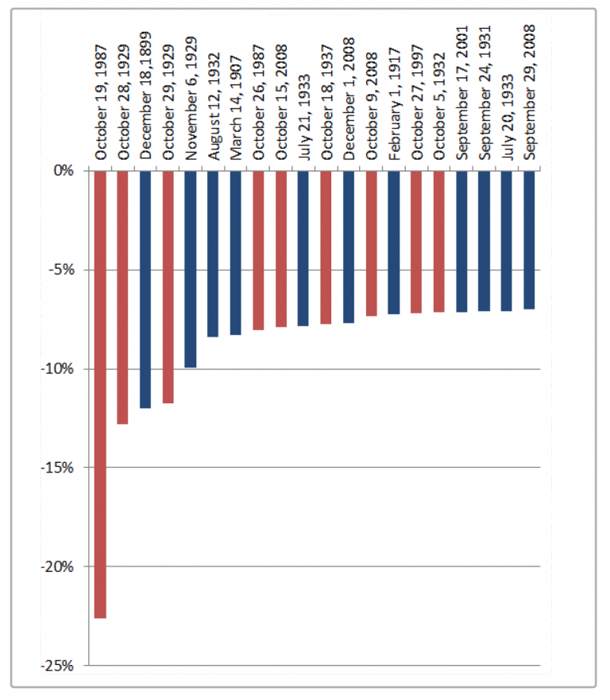

**Bank and Roll!**

**Bank and Roll!**

**Bank and Roll!**

**Options Academy**

This week, we decided to mix ***TA*** with **OA** in hopes of helping NOW and in a Big Way! And quickly!

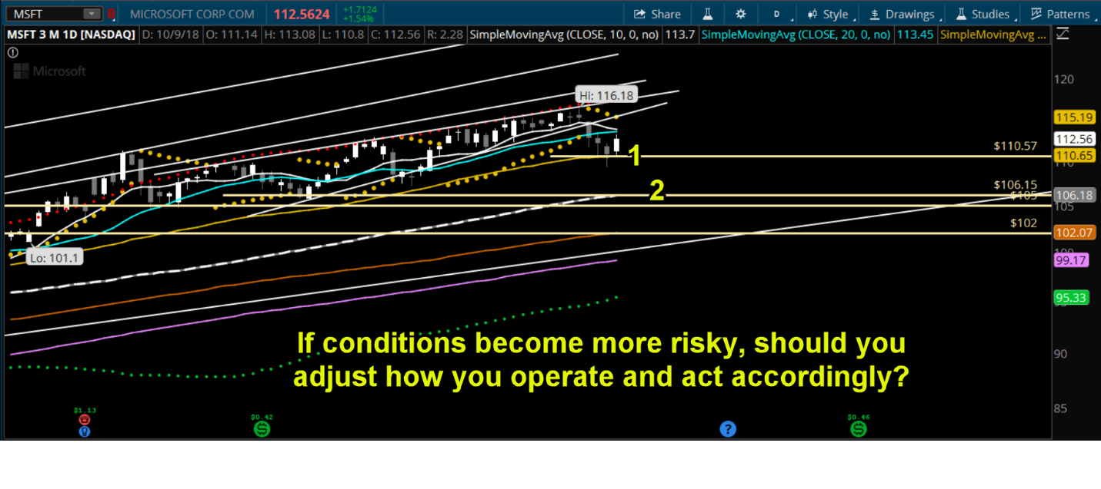

This topic isn’t what we had planned but it may be timely and that’s why it’s here!

We’ll use the graphic above to assist us because this lesson is something that’s lost on newer option traders and it will only help. We’ve labeled support Level 1 and Level 2. **MSFT** looks, after a week of selling, that it may have found support and could be due for a bounce. Not an uncommon happenstance. We can understand why folks would want to “trade the bounce”. That is, buy in as bulls now expecting **MSFT** to power back up and profit. No argument, it could happen. The thing is, should you do it with your usual gusto? OR, should you alter your aggressiveness to suit the situation?

We’re thinking that toning down the gusto wouldn’t be the worst idea! Let’s look at why we feel that way.

Has **MSFT** broke below its support line of the wedge? YES, yes it has, that’s for sure.

Are the moving averages losing a little steam? YES.

Has much of the market, especially TECH of which MSFT is a part of, started breaking down too? YES.

Clearly, there are a lot of concerns and we could add to this list easily:

Is the 50 SMA, a key SMA, just below the current price near where it supported? YES.

Is the market overdue for a selloff? Is October notorious for selloffs? YES and YES!

But, here’s the important part: Shouldn’t we adjust to act properly within this new environment?

We think YES! YES, we should!

So, if you think there’s support at Level 1 above and then Level 2 below and you’d normally buy deep ITM calls at strikes near the Level 2, why do it? Why go with that type of higher delta gusto? In an environment like this we could wake up to a serious futures implosion one morning. If we were super-deep ITM with our calls, we could lose a lot of money on a down gap before even being able to react. That’s why, we’d opt for the ITM calls at a strike just at Level 1 support because we’re still happy if MSFT bounces nicely and we’ll expose a lot less capital to risk if the market decides to implode, as many would argue it is overdue to do.

Options selection isn’t all about the Greeks in our view. Having a deft touch that’s related to the technical picture within the stock’s price chart might make a lot more sense, especially in market maelstrom periods like the one we may be on the cusp of presently.

If you have questions, please ask away in our next **Morning Cal**l webinar. **😊**